Treasurer’s Report
AGM: 28 May 2022
The 2021 accounts have been prepared and reviewed by Helen Reeves, Chartered Accountant, and are attached to this report with a profit and loss summary over recent years.
Our balance of funds as at 31 Dec 2020 was $46,203 and the Association had a net loss for the financial year of $8,518, compared to a closing balance of $54,721 and a net surplus of $10,781 for the previous year. The decrease in funds is mainly attributable to:
- Junior Nationals running at a loss to the Association (which it usually does) but without a Senior Nationals being run in the same year (which usually returns a profit to the Association and offsets the Junior loss to some extent)
- The agreement last AGM to waive Association affiliation levies for the year

As per our Statement of Financial Position, we still have approximately $2,000 of airfares held in credit for future use, being held for future travel by officials e.g. to future Nationals. There were no new assets purchased during the reporting period, and all existing assets have no book value so there was no depreciation.
Given our current bank balance and situation, there is no intention to suggest an increase in Association affiliation fee, membership levies, or other fees, at this time.
I’d like to record my thanks to the club treasurers and secretaries who continue to ensure that levies and other invoices are paid, and to Helen Reeves for her on-going provision of sound accounting advice, and her patience particularly once *again* in working through flight credits.

Yolanda van Dorrestein
NZARRA Treasurer

Summary of Income and Expenditure:

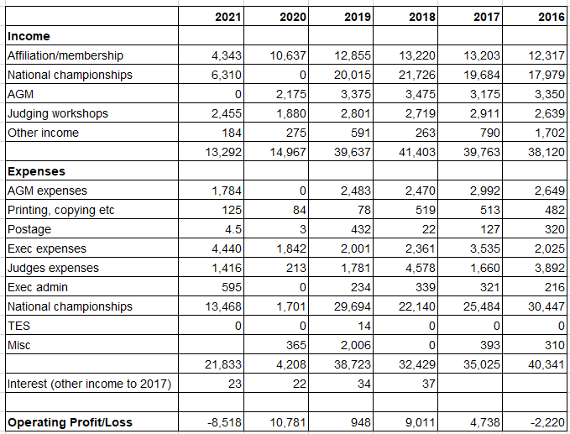

Note that “judges workshops” income is derived from the membership fees paid by clubs, which includes an amount to go towards funding the biennial combined judges workshop, and “AGM” income is derived from the delegate registration included in the annual affiliation levies paid.

To be moved:
- That Association membership fees and affiliation levies remain unchanged for the 2022 year
- That Association affiliation levies and first AGM delegate registration ($300 payable 1st August) be waived for the 2022 year
- That the financial report for 2021 be accepted

