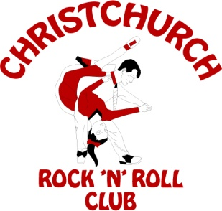
21 Roswell Place
Islington
Christchurch 8042
www.christchurchrocknroll.org.nz

Christchurch Rock n Roll Club
Progress report for Senior
Nationals 2024

The Christchurch Rock n Roll Club organising committee would like to extend an invitation to all Rock n Roller dancers & supporters to come to the Senior Nationals 2024 in Christchurch.

You can be guaranteed a great weekend of fun, good music and fantastic dancing. We once again offer you a great atmosphere at the Lincoln Event Centre - Lincoln.

We have secured the following: Lincoln Event Centre
Bounce Sound System
Roto Rockers
Notes:
- Motels on the list are between 20 minutes travel to the venue. There is only 1 motel in Lincoln township.

We look forward to seeing you in Christchurch in 2024.

Check out our website for further updates.
www.christchurchrocknroll.org.nz

