40th Senior Rock’n’Roll Nationals 2025 Rotorua Rotorua Energy Events Centre
“Rock your Club, Roll your Colours” Queens Drive Rotorua
24th – 26th October 2025
11 May 2025

Hello to all Clubs,

Welcome to the first newsletter for this year’s Senior Nationals. Tauranga Club is well underway with the planning and we can’t wait to see all the club colours together again. This newsletter has some important details so please read and share with your members.

Venue - Rotorua Energy Events Centre, specifically the Southern Trust Sportsdome.
Access is from Queens Drive. Inside we will have tables and chairs set up on the floor and there is additional terraced seating around the hall that will be available.
Here is a link to the venue - https://www.eventsandvenues.co.nz/venues/energy-events-centre-/southern-trust-sportsdrome/

Banners - We have a great place to hang your Club banners! Please send these to our Club President by the 30th of September!
Malcolm Mazur
1893 Cambridge Road
Cambridge 3434

Trophies - We will also require all Senior Trophies to be sent to the same address. A date is to be confirmed for this.

Camping - Unfortunately, there is no camping allowed in the car parking area. This is mostly due to the space being shared with another event taking place in another part of the Events Centre. There is, however an overnight Campervan Parking/Camping Ground 5 mins walk away! The address is 1029 Hinemoa Street. This faces the Polynesian Spa.
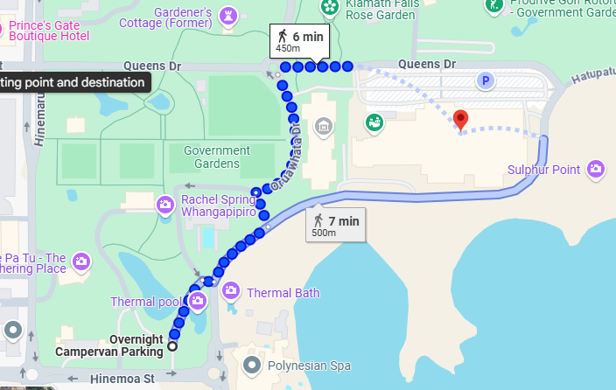
Tickets - Early Bird Tickets sales will start Tuesday 1 July 2025 until Friday 26th September 2025
Please note, Order forms will be sent out to clubs and made available on our Facebook page in due course.
Friday Night Only $20.00
Weekend Pass $100.00
Saturday Full Pass $60.00
Sunday Full Pass $60.00
Please note that Friday will be free entry for Weekend, Saturday and Sunday Full Passes.
Saturday Day / Saturday Night $35.00 per session
Sunday Day / Sunday Night $35.00 per session
Please note that these sessions do not include Friday night entry.
All early bird tickets will be couriered to clubs nominated address.

After Early Bird
Friday Night Only $20.00
Weekend Pass $110.00
Saturday Full Pass $65.00
Sunday Full Pass $65.00
Please note that Friday will be free entry for Weekend, Saturday and Sunday Full Passes
Saturday Day / Saturday Night $40.00 per session
Sunday Day / Sunday Night $40.00 per session
Please note that these sessions do not include Friday night entry

Any tickets purchased after Early Bird Closes will need to be collected at the door on the day.
Ticket sales finish Friday 17th October. There will be NO DOOR SALES.
Any questions regarding tickets, please phone Malcolm Mazur on 0273116080
As the plans are still being made, we will be sending out our next newsletter in June with further information and updates. In the meantime, we wish you well with your training! Let the countdown begin! 24 Weeks to go!
Kind regards,
Tauranga Rock’n’Roll Club

